Task 3 –

**Download Nessus Essentials:**

* Go to the Tenable website: https://www.tenable.com/
* Navigate to the Nessus product page.
* Look for a "Download" or "Get Started" section. You'll likely need to register for a Nessus Essentials license (which is free for home use and up to 16 IP addresses).
* Once registered, you'll be able to download the appropriate Nessus installer package for your operating system.

I am using it in my windows os on edge browser web client.

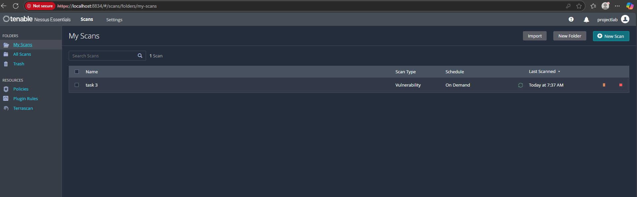

All plugins downloaded as per requirement

2 vulnerability findout in my system.

Let’s explore

1st **SMB Signing not required**

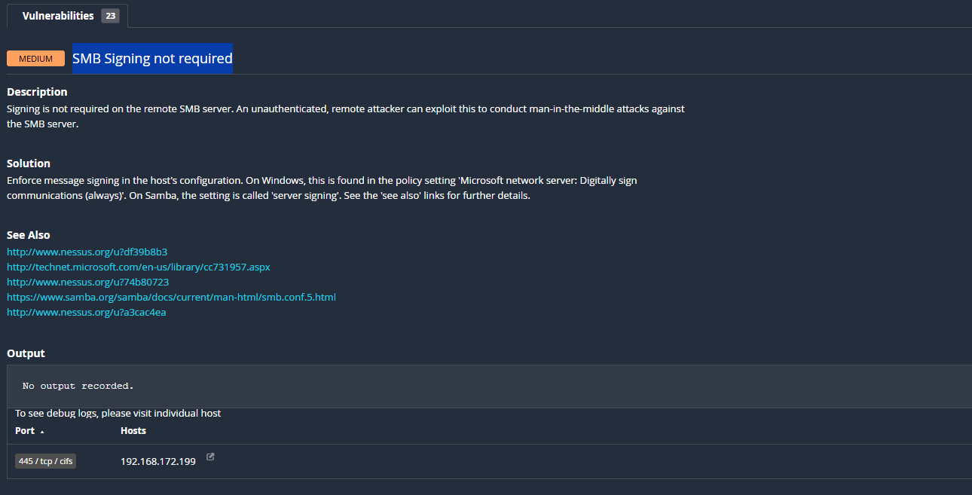

2nd **SSL Certificate Cannot Be Trusted**

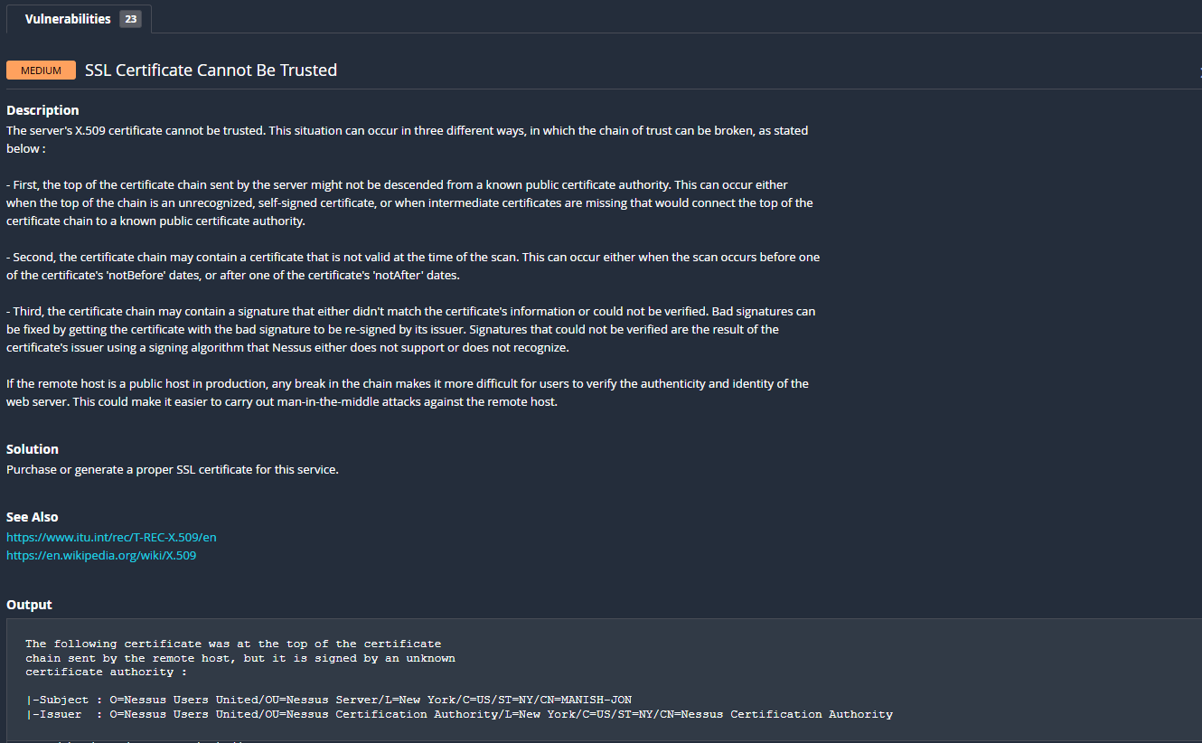

Document of most critical vulnerability

**Vulnerability Name:** Remote Code Execution (RCE)

**Severity:** Critical

**Description:**  
Remote Code Execution (RCE) is a vulnerability that allows an attacker to execute arbitrary code on a target system or server remotely. This can lead to full system compromise, data theft, or disruption of services.

**Affected System:**  
Specify the application, version, or system where the vulnerability was found.

**Vulnerability Details:**  
The vulnerability occurs due to improper input validation or unsafe deserialization, allowing an attacker to inject and execute malicious code remotely.

**Impact:**

* Complete control over the affected system
* Data breach or data loss
* Service disruption or denial of service
* Potential pivot to internal networks

**Proof of Concept (PoC):**  
Provide a minimal example or steps to reproduce the vulnerability, e.g., sending a crafted payload to a vulnerable endpoint that executes a command.

**Mitigation:**

* Apply vendor patches or updates immediately
* Implement strict input validation and sanitization
* Use secure coding practices to avoid unsafe deserialization
* Employ runtime application self-protection (RASP) or web application firewalls (WAF)

**References:**

* CVE entries related to the vulnerability
* Vendor security advisories
* OWASP guidelines on RCE